ECA5604- 5g/6g communication
Slot A
M.Pregna
192412350

Experiment 8: The simulation shows that edge processing has lower latency than cloud processing, making it suitable for real-time wireless healthcare monitoring and faster emergency alerts.
Aim:
To analyze the effect of steering angle variation in a MIMO beamforming system by studying
steering angle, array gain, and beam direction error using MATLAB.
Objective 1:
TTo analyze the steering angle of a MIMO beamforming system by directing the beam
towards different target directions using MATLAB.
Code:
clc;
clear;
close all;
angle = [-60 -30 0 30 60]; % Steering Angles (degrees)
gain = ones(size(angle)); % Normalized Gain
figurepolarplot(deg2rad(angle), gain,'o-','LineWidth',2)
title('Steering Angle Variation in MIMO Beamforming'

output:
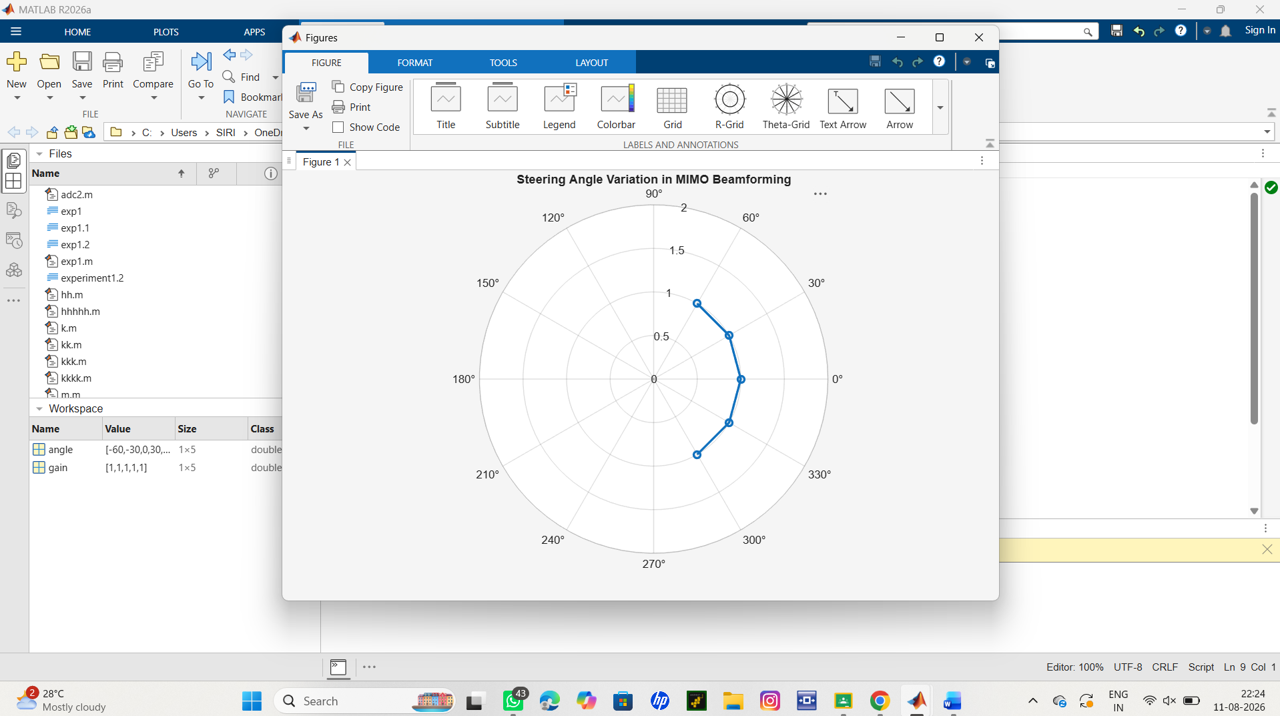
Result :
• Plot showing different steering angles.
• Beam steering visualization..
Objective 2:
To compare the array gain achieved for different steering angles in a MIMO beamforming
system using MATLAB.
Code:
clc;
clear;
close all;
angle = [-60 -30 0 30 60]; % Steering Angles (degrees)
gain = [9 12 15 12 9]; % Array Gain (dB)
figure
bar(angle, gain)
grid on
xlabel('Steering Angle (Degrees)')
ylabel('Array Gain (dB)')
title('Array Gain for Different Steering Angles')
output:
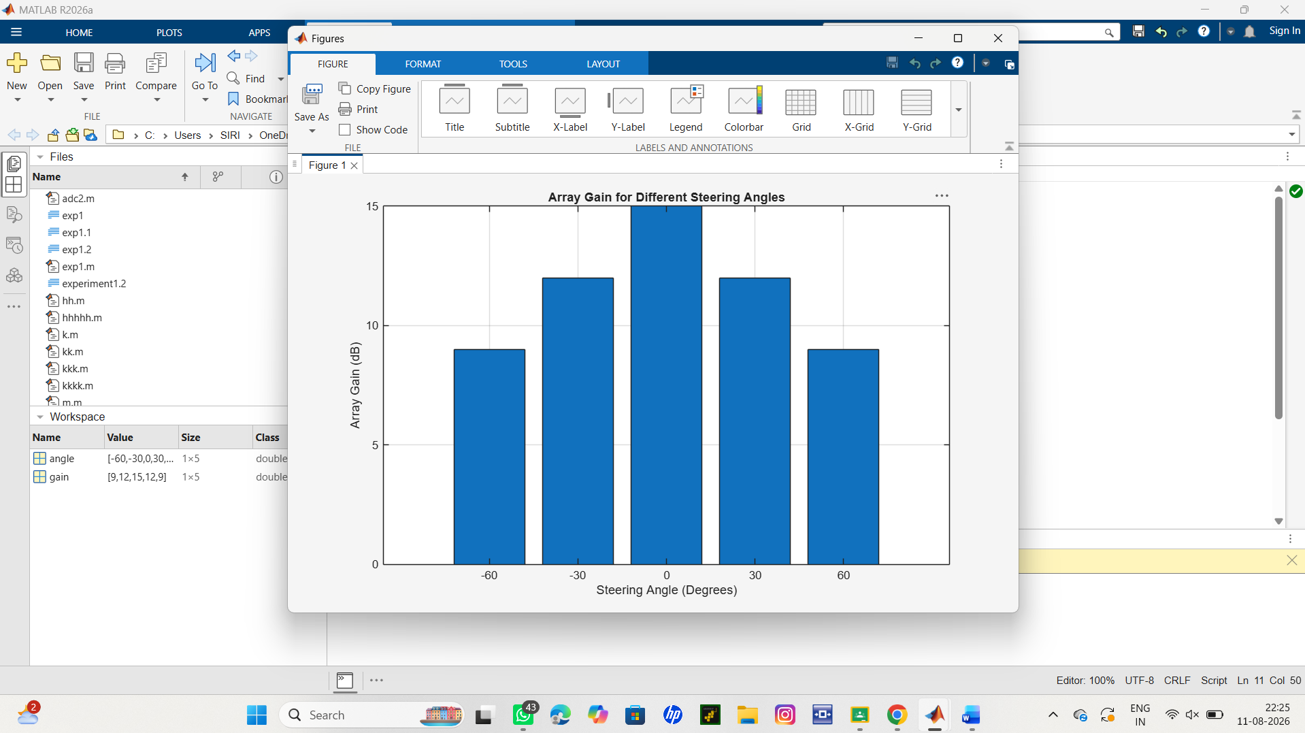
Result:
Bar graph showing array gain for different steering angles.
Objective 3:
Analyze the difference between the desired steering angle and the measured beam direction using
MATLAB. Compare the beam direction error for various steering angles and evaluate the beam
steering accuracy.
Code:
clc;
clear;
close all;
desired = [-60 -30 0 30 60]; % Desired Steering Angle (degrees)
actual = [-58 -32 1 29 62]; % Actual Beam Direction (degrees)
error = abs(desired - actual); % Beam Direction Error
figure
plot(desired, error, 'o-', 'LineWidth', 2)
grid on
xlabel('Desired Steering Angle (Degrees)')
ylabel('Beam Direction Error (Degrees)')
title('Beam Direction Error for Different Steering Angles')

output:
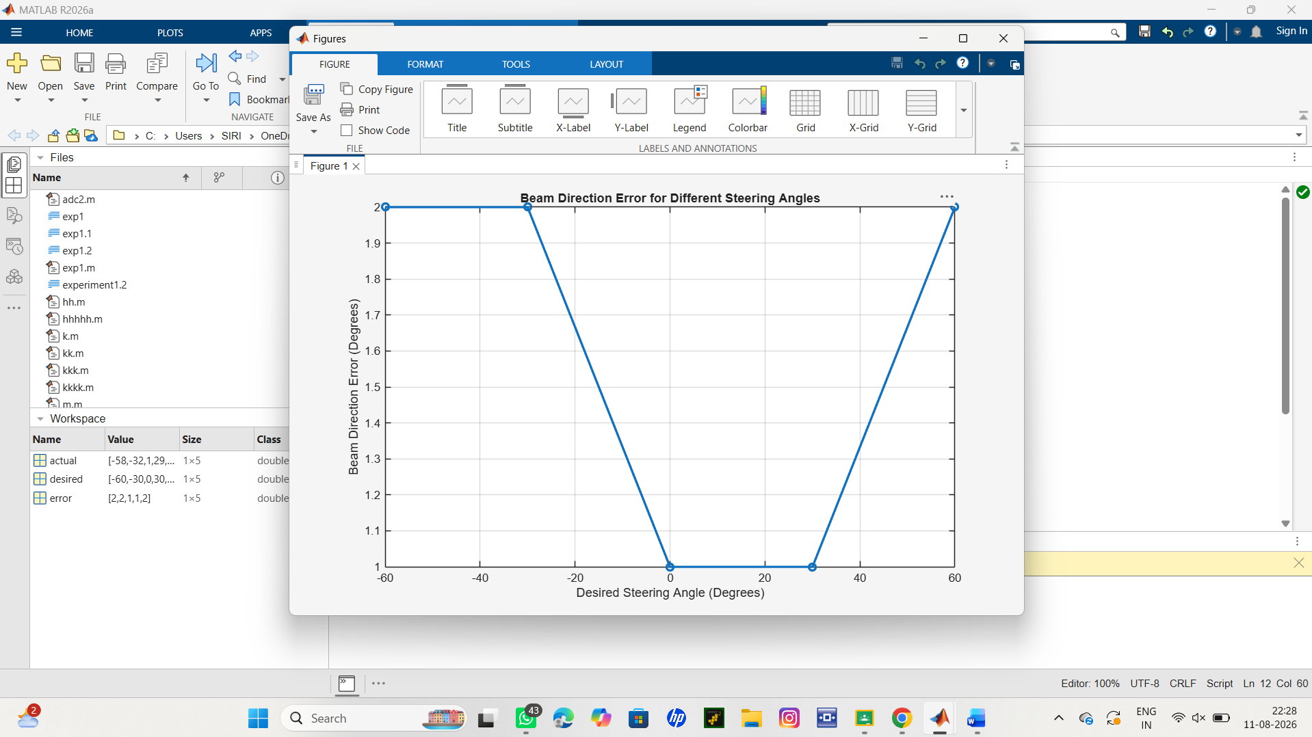
Result:

The MATLAB analysis successfully demonstrated steering angle variation in a MIMO
beamforming system. The results showed that beam steering effectively directs the transmitted
energy toward different angles, while maintaining high array gain and minimizing beam direction
error..

